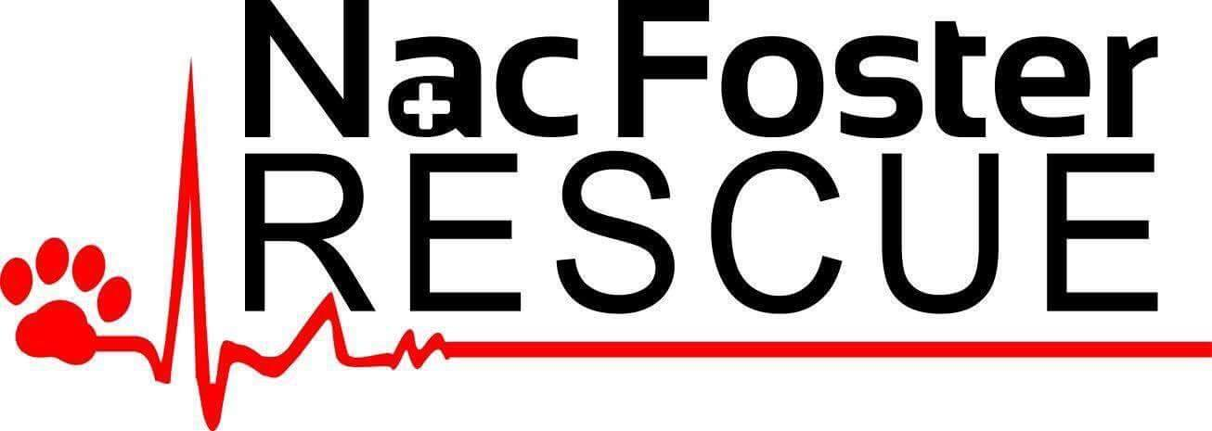
638 N. University Drive #247, Nacogdoches, TX 75961
nacfosterrescue@gmail.com

Foster Liaison Program and Guidelines

First, we want to thank you for giving of your time, love and home to a foster dog. Fostering provides a temporary home prior to adoption to an NFR approved family or transport to an NFR approved rescue. YOU are saving the life of a family pet and we are grateful!

Nac Foster Rescue Board Members:

Kelly Floyd 936-645-0304
Cynthia Foster 936-552-9493
Debbie Wise 936-585-1099
Lisa Page 936-554-9075

Your NFR liaison is: ________________________________________. Please feel free to contact any of the ladies named above if your liaison cannot be reached.

A home visit by a representative with NFR will be performed prior to fostering. A home visit will help ensure the home is “dog proof” and answer questions you may have concerning your potential new foster dog.

Supplies - If needed, Nac Foster Rescue will provide:

- Bowls for food and water.
- Dog food.
- Dog bed.
- A safe/secure crate if needed. The crate should be large enough for the dog to stand in and turn around but not much larger than that.
- Dog treats appropriate to the size of the dog. Treats are a great way to train and build a positive relationship with your foster dog.
- Dog toys that are durable and appropriate to the size of the dog.
- Collar and leash.
- Monthly Heartworm preventative.
  - Provided by NFR.
- Monthly Flea/Tick preventative.
  - Provided by NFR.

Name:
Address:
Contact number where you can be reached the best time to contact you:
Email address:
Are there other adults in your household? No___Yes___ (If yes, indicate if each is committed to becoming a foster family)

Are there children in your household? No___Yes___ (If yes, give their names and ages)

Will any of your children be responsible for caring for your foster dog? No___Yes___ (If yes, please explain)

Is anyone in your household allergic to animals? No___Yes___ (If yes, please explain)

Number of personal pet(s) _____ (please describe them as to their breed, age, size, and temperament particularly with regard to other dogs).

Are the pets in your home current on all vaccines? _____ Spayed/Neutered? _____

Please list two people who are knowledgeable about your care of dogs/cats. Please include your vet as one of them. List their names, email addresses or phone numbers, what is their relationship to dogs, and what is their relationship to you.

HOME ENVIRONMENT
Do you ___own or ___rent your property? (If you rent, do you have permission from your landlord to have pets on the property? yes___no___)
Are there any restrictions as to the number of dogs and /or combination of dogs and cats that you may have at your residence? No___Yes___I am not aware of any____.
Are you required to obtain a city tag if you take in dogs in addition to your own? No___Yes___
Do you have a fenced yard or outdoor kennel run? No___Yes___ (If yes, what type and how high is it?)
How many foster dogs can you provide for at a time?
Where will foster dogs be housed?

CARE AND TRAINING
You may be asked to take a dog in your care to NFR’s veterinarian to be spayed/neutered or for other routine care. Would you be willing to assist with that? Yes___No___
If you are unable to assist, please contact your Nac Foster Rescue Liaison.
Please check the areas of evaluation you are able to provide:
____Temperament for ordinary household
____Suitability for placement in a home with children ten or older
____With children younger than ten, ____toddlers, ____babies
____Suitability for placement in a home with other dogs and/or cats
____Other (please explain)
House training, ___crate training, ___walking on a lead
____Basic training (including sit, down, stay, and heel)

FOSTER/VOLUNTEER'S AGREEMENT

This agreement is made and entered into this _______ day of ________________, 20____, by and between Nac Foster Rescue and the following individual(s), hereinafter "Foster." This agreement is valid for any future animals in Foster's care on behalf of Nac Foster Rescue.

- Foster agrees to work with Nac Foster Rescue and to abide by any decisions made by them.
- Foster will never knowingly falsely represent themselves or any dog/cat in their care.
- Foster understands that the dog is the property of Nac Foster Rescue.
- Foster agrees to not transfer custody of the dog to anyone without the knowledge of Nac Foster Rescue. Foster furthermore agrees to return the dog to Nac Foster Rescue upon demand.
- Foster will contact the assigned liaison or a board member immediately if the dog becomes ill or is missing.
- Foster agrees that the costs of any veterinary care not approved by a Nac Foster Rescue board member in advance of the dog receiving such care will be the financial responsibility of the foster. This includes, but is not limited to dental care, blood-work, x-rays, lump removal and other non-emergent care.
- Foster agrees to obtain immediate veterinary care for the dog in the event of a medical emergency to stabilize the dog and to contact assigned liaison or board member as quickly as possible for approval of other medical expenses. Medical emergencies include dogs hit by cars, collapsing, suffering strokes, heartworm treatment complications, poisoning, broken bones, severe wounds from dog fights, and other events of a life-threatening emergency.
- Foster will provide fresh food, fresh water, and plenty of exercise daily.
- Foster agrees to always keep the foster dog within a fenced yard or supervised on a leash; Foster agrees to never leave this dog outside when no one is home, to never allow the dog to be tied to a doghouse or to a chain, nor left unsupervised in a yard for extremely long periods.
- Foster has been advised that foster dog may have been neglected, mistreated, or abused in the past and that special care of precautions may be required. Foster also understands that the dog may need medical care which will be provided by Nac Foster Rescue.
- Foster understands that interactions between children and foster dog must be carefully supervised. Any dog in rescue is carefully screened, but dogs are dogs and unpredictable on occasion and especially in new surroundings

It is further agreed that if the Foster fails to perform any of those acts which he/she has agreed to perform, Nac Foster Rescue may, at its option, revoke this agreement and retake possession of the dog immediately upon demand. Foster agrees to hold harmless and release Nac Foster Rescue and/or its members, volunteers and other individuals working for and/or assisting with rescue from all liability, claims, and/or causes of action arising from any acts, injury and/or occurrences engaged in and/or caused by the dog(s) subject to this agreement.

FOSTER HAS READ THE FOREGOING FOSTER CONTRACT AND FULLY UNDERSTANDS AND AGREES TO ITS PROVISIONS. DATED:

___________________, 20__________.

____________________________________________________________________________
Signature Printed Name

______________________________________________________________________________
Residential Address

________________________________ ______________________________________
Phone Number Email address

